Title or Task: | Set Up Files Templates  
Description: | Creating files on school drive with copies to flash drive.
Files Required | Thumb Drive USB 2gb prefered
Suitable for Classes: | AIT • Multimedia • Cert II IT • Cert II Bus
Area: | Technology & Enterprise
Teacher: | Mr Peter Faulks
Timeline | Lessons 1 through 4 (student paced)
Date Due: | This week
Task Brief: | Create files for school
Outcomes: | Set up files start a web site

Items highlighted in yellow are tasks for you to complete
Items in Blue italics are help tips

Lesson 1 - Start here

Create a folder that will become your web site : (title depends on subject) AIT1, AIT2, AIT3, Cert II, or Multimedia etc (Whatever is the title of your course) you can add the Term Number if you wish.
We will use AIT2 Term 1 in our sample
Now create these folders inside the AIT2 Folder

- Task 1

Inside AIT2
- Task 2
- Task 3
- Task 4
- Task 5
- Assets
- Marking Folder
Take a screen shot of your files inside AIT2 (Press Prt Scr) button and Ctrl V (Paste) into a word document.
Save the document as
Your initials_files.doc into the Marking Folder
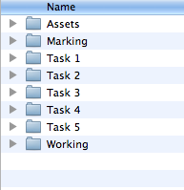
I will look at this in 5 minutes.
AIT2 Folder

Save the set of folders to a Flash Drive if you have one (Always backup your work)

Next lesson we will create our web site Cover pages for each task

This will complete today’s lesson
Lesson 2 Advanced students ready to proceed… Starting your web page

Open Dreamweaver
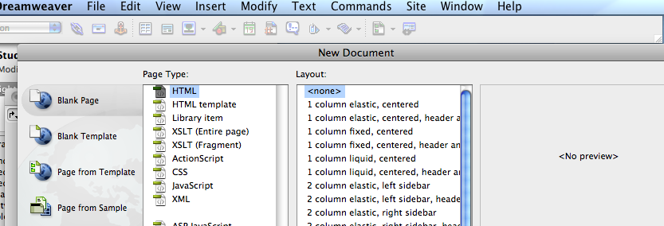
New
HTML page
<none>

Click Create

Create a new site = Site New Site…
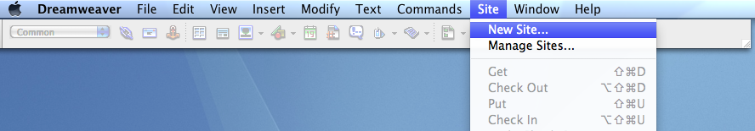

Change the title to AIT 2 (or your subject)

Give this your name i.e AIT2 Ima Student and then find your site on the network or on your thumb drive (We will use the thumb drive for this exersize)

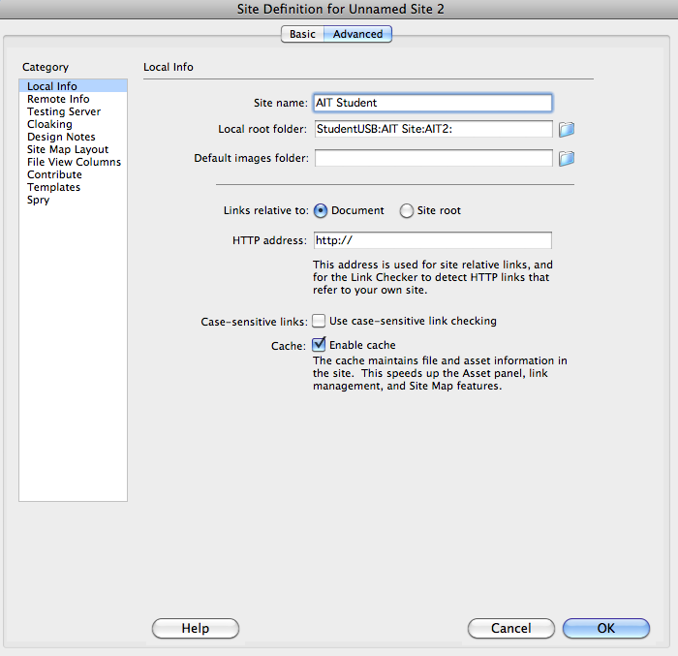
Click OK

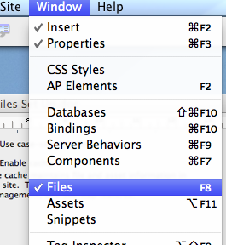

Ensure you are showing Files

Window Files

Your site should look like this

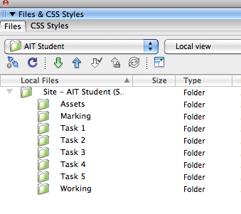
I will check your site if you wish

Saving our first page (usually known as a Splash Page index.html)

You should have a plain white page open this we will make more exciting as we develop our site…

Lesson 3 these lessons will continue on but students can stop here and check their work, if you feel you can continue do s, but we will start (reiterate) Lesson 3 as per below.

Type your name and center it on the page, choose a colour for your font (drag across to select text) and make this Heading 1

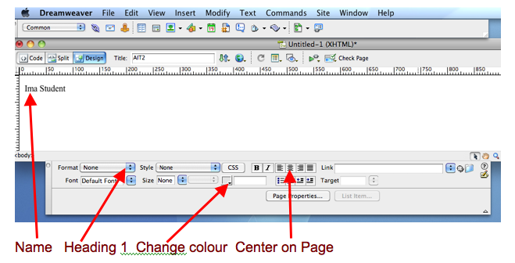

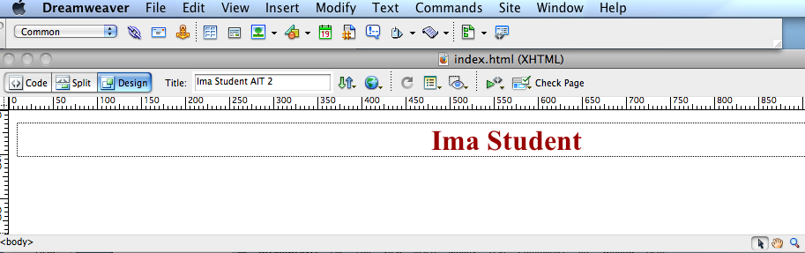

Add your name to the Title box then save this page as index.html to your web site folder
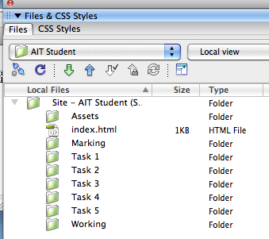

Your site should look like this.

Everyone should now turn to the student on their right and pat their should and say

"Congratulations you are now a web developer"

You have successfully create your first web page



You have made your first web page
Now we can start to improve our page
Open page properties (Modify - Page Properties…)

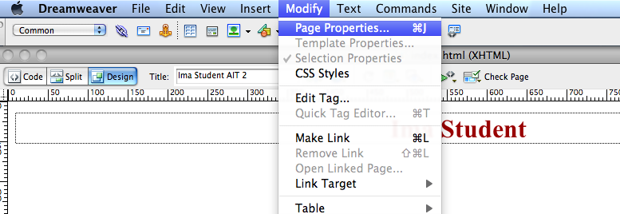

and
select the background colour
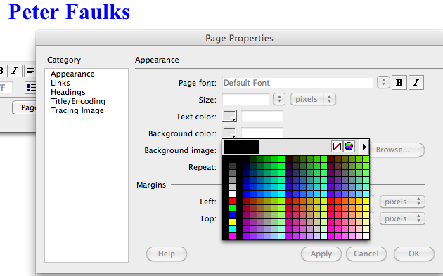

Select a colour Click Apply then OK
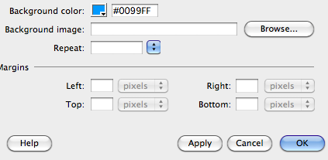

Lesson 4

We now need to copy this table into your web page
To do this open AITSite.html then copy the table into your site using Copy & Paste - put the cursor to the right and drag left to select the table…
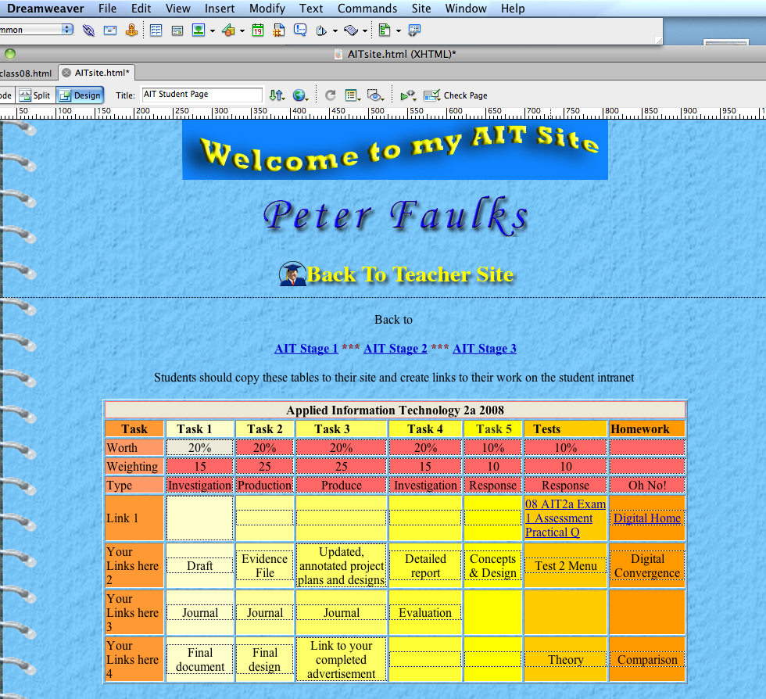

Add the year, your school and any details that you wish (we will add your photo next lesson)

You can also run the Dreamweaver Tutorials tutorial and work through ADW100 or ADW101

http://www.peterfaulks.net/Teaching/Tutorials/dreamweaver.html
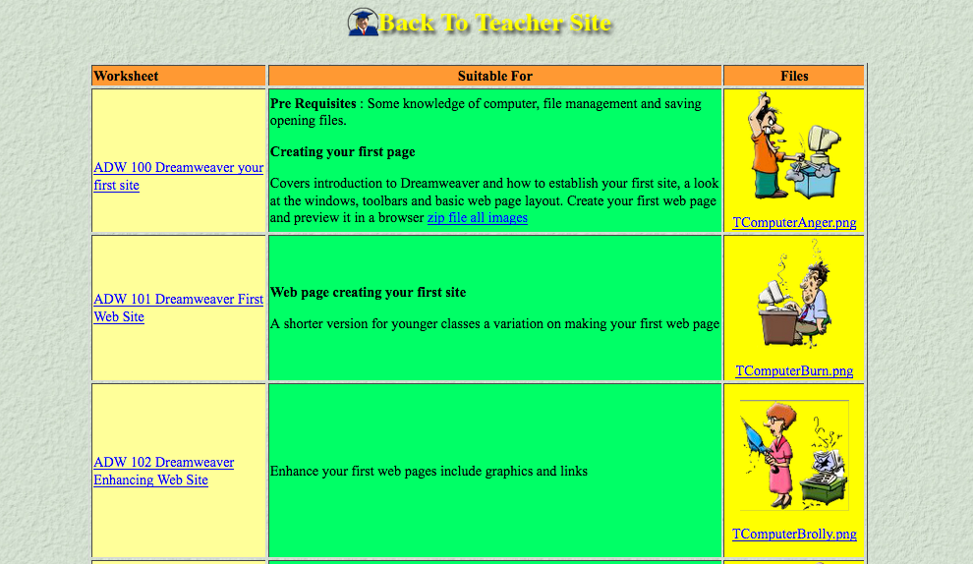

your page should now look like this with a table ready for your links

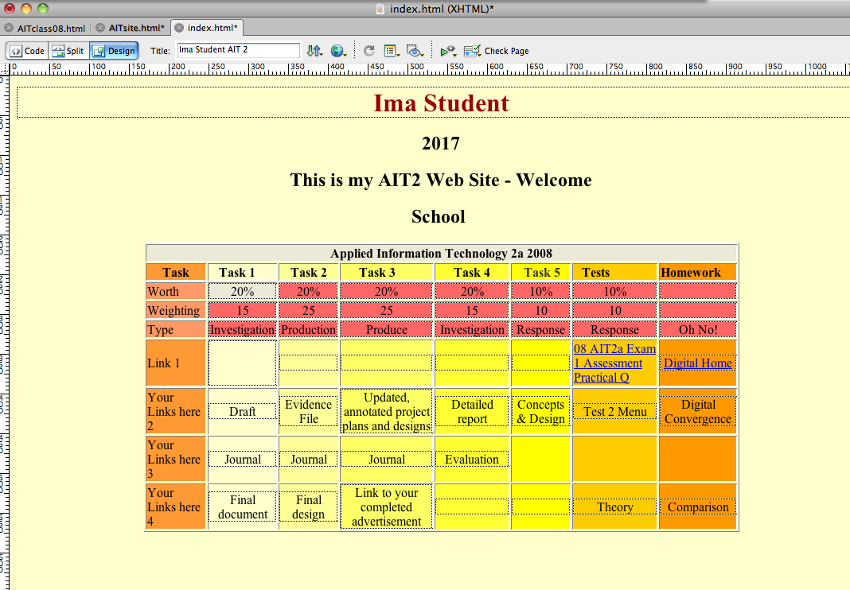

We will create links for documents in our next lesson

This ends this set of lessons

The following are notes and information sheets

Files
Regardless of which application you are using, you should save your work regularly to prevent losing anything that you have created. But where do you save it to? I have create starting template documents for you, some of these will also link to a web page you will create later, all of these will need to be personalized by YOU.

NB: a number of the instructions here relate to Microsoft® Windows® or Linux® Operating Systems. If you are using an Apple® Macintosh® Operating system you will need to investigate the relevant commands.

Your computer is like a filing cabinet. It can hold a great deal of information which, if stored correctly, is quickly and easily accessed. In most filing cabinets information of a similar nature is grouped together into sections, files or folders.


On you computer, data is also stored in files and folders. Have a look at the image below.
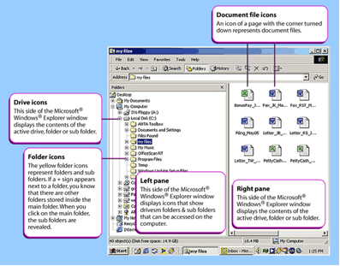
All files have a name and an icon. Most operating systems (except Apple® Macintosh® Operating Systems) have file names which contain an extension of up to three letters or characters after a full stop eg ‘Program.doc’. File name extensions can tell you what type of file it is. See the table below for some examples.

Naming files
It is important to name your files correctly. Firstly, it helps you identify the files easily and secondly, it assists your system to work efficiently. Incorrectly named files will not be saved properly and you could lose your work.
There are a couple of rules (or naming conventions) which need to be followed when naming files:
• filenames should not contain any spaces (use an underscore _ instead)
• filenames should only contain letters or numbers, not symbols such as #, * and \
• filenames should be written in lowercase.

In this course you will find suggestions for naming each of your files. You should always add your initials to the front of the file name. For example Emily Jones could name her week 5 journal entry as:

ejwk5task1 or ej_wk5task2

Identifying file properties
By using the right mouse button when you click on a file you will see a drop down menu from which you can select Properties. A dialogue box should appear giving you information on the file such as the type of file it is, what application it opens with, when it was created and when it was last modified.

Renaming a file
You can rename a file using the right mouse button. Select Rename from the drop down menu. Type in the new name and press the Enter key.

Copying a file
You can use the right mouse button to click on a file and then select Copy from the drop down menu. You then need to open the new location for the file, open the folder and click the right mouse button and select Paste from the drop down menu.

Warning
Having multiple versions of the same file can prove confusing. You might accidentally use the wrong version. It is a good idea to rename versions so you can keep track of which version is the most current. This is just as important for backup files.

Moving a file
If you want to actually move a file without making a copy of it:
• Select the file with the left mouse button
• Click on Edit on the toolbar
• Select Move to Folder
• Choose the new location in the dialogue box
• Click on Move.
You can also select the file by using the left mouse button and while holding the button down, drag the file to the new location.

Deleting a file
There are a number of ways to delete a file. You can:
• use the right mouse button to click on the file you wish to delete
• select Delete from the drop down menu.
You can also:
• select the file with the left hand mouse button
• press the Delete key on the keyboard.
You can also click and drag the file to the Recycle Bin or Trash Can on the desktop.

Regardless of which method you use, a dialogue box should appear querying if you wish to delete the file. You can select yes or no.

If you delete a file by mistake, you can still restore it as long as you have not deleted it from the Recycle Bin or the Trash Can.

